Evolution & Genetics Notes Part 1

What did Darwin’s Travels reveal?
- The _______________ of living species was far greater than anyone had previously known!!
- These observations led him to develop the theory of ________________________!!
How did tortoises and birds differ among the islands of the Galapagos?
- Each island had its own type of tortoises and birds that were clearly __________________ from other islands
Evolution is when organisms change over time. So, modern organisms ____________ from ancient ones
Evolution is a Theory – Just like Gravity!
- Evolution is a well-supported explanation of phenomena that have occurred in the natural world
- A theory in science is a well-tested _______________________, not just a guess
Previous Theory by Lamark - Theory of acquired characteristics
- Lamark said organisms ___________________ traits by using their bodies in new ways
- These new characteristics were passed to ____________________________
- 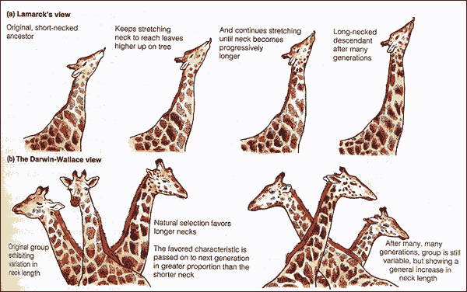Lamark was totally wrong!

Darwin finally published his ideas in 1859
- Other naturalists were _________________________ the same theory that Darwin did.
- Even though he was afraid of the Church’s reaction to his book he wanted to get credit for his work.

Artificial Selection
- nature provides variation, ________________________ select variations that are useful.
- Example - a farmer breeds only his best livestock
Natural Selection
- The traits that help an organism survive in a particular environment are ______________ in natural selection
Natural Selection and Species Fitness
- Overtime, natural selection results in changes in the ______________________ characteristics of a population.
- These changes increase a species _________________________ (survival rate)
Survival of the Fittest
- populations with the most _____________________ traits and ability to compete will live long enough to reproduce and pass on those beneficial traits.
6 key points of Natural Selection and Survival of the Fittest
- _____________: living things produce more offspring than needed for the species to survive
  - Ex. Populations remain constant because only a small fraction live long enough to reproduce (food is a limiting factor)
- _________________: struggle between organisms for food, shelter, mates and living space
  - Ex. Resources for life are limited so an organisms must compete within its species and with other species to survive long enough to reproduce
- __________________: differences (structural, molecular, and behavioral) within a species that makes individuals different
  - Ex. Individuals vary in their abilities to get food, escape enemies, or find and attract a mate
- ____________________: inherited traits that improve an organisms chances of survival and reproduction in a certain environment “Survival of the Fittest!”
  - Ex. Individuals that are better adapted to the environment will live long enough to reproduce
  - Camofluage or blending coloring
- ____________________: Individuals that have favorable traits and better adapted to survive will pass on these traits to future offspring
  - Ex. Good genes survive and bad ones are eliminated
- _____________________: A new species is formed over many generations of favorable adaptations gradually accumulate and non-favorable ones disappear.
  - Ex. So many gradual changes accumulate that a new species emerges

Camouflage
- Blends into the _____________________________
Warning Coloration
- Shows a predator (or prey) that they are ________________________ to eat.
Mimicry
- Resembles another species to gain an __________________________ at survival
Speciation
- Favorable _______________________ accumulate
- Unfavorable disappear
    - All changes may eventually result in a ___________________ species
Mutations
- Source of genetic ________________________
- May be harmful or helpful
  - The ________________________could turn a harmful allele into a helpful trait
Summary of Darwin’s Theory
- Organisms differ; variation is _____________________
- Organisms produce more offspring than survive
- Organisms ______________________ for resources
- Organisms with advantages survive to pass those advantages to their children
- Species alive today are descended with _____________________ from common ancestors

Evolution & Genetics Notes Part 2

Evidence of Evolution
- Fossil Record
  - Law of ___________________
  - Theory of plate _____________
- Geographic Distribution of Living Species
- Comparative Anatomy
  - ______________________ structures
  - Analogous structures
  - _________________ structures
- Similarities in Embryology
Evidence of Evolution – Fossil Record
- Fossil Record provides evidence that living things have ______________________
- Fossils show the history of life on earth and how different groups of organisms have changed over time
Relative vs. Absolute Dating
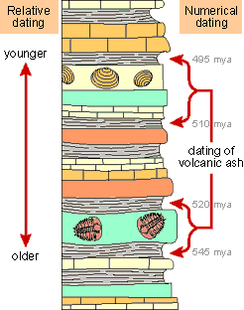
Relative Dating
- Can determine a fossil’s relative age
- Performed by estimating ______________ compared with that of other fossils – law of superposition
- Drawbacks – provides __________ info about age in years
Absolute dating
- Can determine the absolute age in ___________________
- Is performed by radioactive dating – based on the amount of remaining radioactive isotopes
- Drawbacks - part of the fossil is _____________________ during the test
Theory of Plate tectonics
- A theory that states that the earth’s crust is made up of a number of ______________ which move over a liquid crust that get created and destroyed over time.
Pangea
- Two hundred million years ago (Ma), research suggests that all the continents were one large mass which was named ___________________.
- Terrestrial organisms were able to migrate across all the continents and were only ______________ by their biotic potential.
Biodiversity
- As Pangea began to separate into separate continents 130 Ma, creating physical barriers such as seas, restricting _______________ to within the continents.
- Gene pools of species are separated and as they are exposed to different physical (i.e. climate) and biotic (i.e. change in predators) conditions, each portion of the species ___________________ differently and eventually forms new species on the separated continents.
- This process is known as _______________________.
- Changes in physical and biotic conditions will also lead to the creation of new species increasing the diversity of habitats and _________________.
- This also provides the space for new species to evolve into these habitats.
- The end result of the separation of Pangea into today’s continental configuration is that plate tectonics has been one of the main driving forces promoting ____________________ of organisms.
Evidence of Evolution - Geographic Distribution of Living Species
- Similar animals in different locations were the product of different lines of ____________________
Evidence for Evolution – Comparative Anatomy
- ______________________________ Body Structures
  - Structures that have different mature forms but develop from the same ____________ tissues
  - e.g. Wing of bat, human arm, leg of turtle
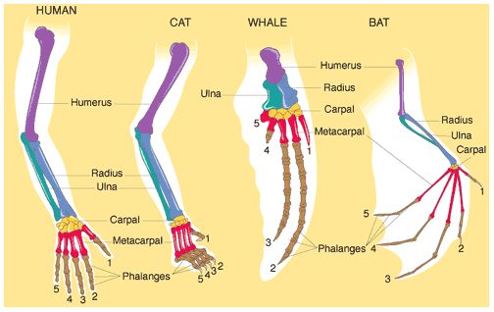
Evidence for Evolution – Comparative Anatomy
- ________________________ structures
    - Similar functions, but different internal structures
    - _____________________: birds and insects wings both are used for flying
    - ___________________: internal structures and embryo development are very different
Analogous Structures

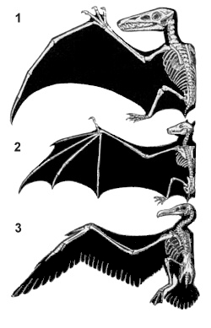
Evidence for Evolution – Comparative Anatomy
  - ____________________ structures
    - remnants of structures that were once functional in an ancestor (now-reduced in size and serve little or no function
    - Examples: Tail bone: (coccyx) remnant of a reptilian tail, _________________, Muscles that move nose and ears
    - Whales and snakes have hind leg bones imbedded in their bodies from four legged ancestors
    - Molecular similarities-genetic DNA code and proteins

Evidence of Evolution - Similarities in Embryology
- In their early stages of development, chickens, turtles and rats look similar, providing evidence that they shared a ____________________________________.
Embryological development
