Earth History Notes Part 1 – Fossils & Relative Age

The Principle of Uniformitarianism
- Uniformitarianism is the idea that the same geologic processes shaping the Earth today have been at work _____________________________ Earth’s history.
- To explain Earth’s history, most scientists supported the principle of ___________________________.
- Catastrophism is the principle that geologic change occurs suddenly.
- The science involved with the study of past life is called ___________________________________-.
- Paleontologist study ___________, which are the remains of organisms preserved by geologic processes.

How do fossils form?
- Fossils are the preserved remains or traces of ______________________ things.
  - Fossils provide evidence of how life has ______________________ over time.
  - Fossils also help scientists infer how Earth’s surface has changed.
  - Fossils are clues to what past _____________________________ were like.
- Most fossils form when living things die and are buried by sediments. The sediments slowly harden into rock and ____________________ the shapes of the organisms.
- Fossils are usually found in sedimentary rock.
- ___________________________rock is the type of rock that is made of hardened sediment.

What are the different kinds of fossils?
- Fossils found in rock include petrified fossils, molds and casts, carbon films, and trace fossils.
- Other fossils form when the remains of organisms are preserved in substances such as tar, amber, or ice.
- _____________________ Fossils
  - A fossil may form when the remains of an organism become petrified.
  - Petrified means “turning to stone”
  - Petrified fossils are fossils in which _____________________ replace all or part of an organism.
- ____________________ and _____________________
  - A mold is a ____________ area in sediment in the shape of an organism or part of an organism.
    - A mold forms when the hard part of the organism such as a shell, is buried in sediment.
  - A cast is a ______________________ of the shape of an organism.
    - Water carrying dissolved minerals and sediment may seep into the empty space of a mold. If the water deposits the minerals and sediment there, the result is a cast.
- Carbon films
  - An extremely thin coating of ______________________ on rock.
HOW DOES A CARBON FILM FORM?
  - When sediment buries an organism, some of the materials that make up the organism can become _______________________. These gases escape from the sediment, leaving carbon behind. Eventually, only a thin ________________________ of carbon remains.
- Trace fossils
  - Trace fossils provide evidence of the activities of _______________________ organisms.
  - A fossilized ______________________ is on example of a trace fossil.
  - Other examples of trace fossils include the trails that animals followed or the burrows that they lived in.
- Preserved Remains (premineralized remains)
  - Some processes preserve the remains of organisms with little or no change.
    - Some remains are preserved when organisms become trapped in ________________.
    - Ancient organisms also have been preserved in amber. ________________ is the hardened resin, or sap, of evergreen trees.
    - ________________________ is another way in which remains can be preserved.

What do fossils tell about how organisms have changed over time?
- The fossil record provides evidence about the history of life on Earth. The fossil record also shows that different groups of organisms have changed over _____________________.
- The fossil record reveals a surprising fact: fossils occur in a particular order.
  - Older rocks contain fossils of _______________ organisms. Younger rocks contain fossils of more complex organisms.
  - In other words, the fossil record shows that life on Earth has __________________, or changed.
- The fossil record provides evidence to support the theory of evolution.
- A scientific ___________________ is a well-tested concept that explains a wide range of observations.
- Evolution is the gradual change in living things over long periods of time.
- The fossil record shows that millions of types of organisms have evolved.
  - But many others have become extinct.
  - A type of organism is ________________ if it no longer exists and will never again live on Earth.
- Paleontologists use fossils to build up a picture of Earth’s environments in the past.
- Fossils also provide evidence of Earth’s climate in the past.
- Scientists can use fossils to learn about changes in Earth’s ____________________________.
How do geologists determine the relative age of rocks?
- When you look at a rock containing a fossil, your first question may be, “How old is it?”
- The ___________________________________ of a rock is its age compared to the ages of other rocks.
- The relative age of a rock does not provide its absolute age
  - The ____________________________ of a rock is the number of years since the rock formed.
- The position of Rock Layers
  - Geologists use the law of _________________________ to determine the relative ages of sedimentary rock layers.
  - According to the law of superposition, in horizontal sedimentary rock layers the oldest layer is at the ______________________. Each higher layer is younger than the layers below it.
  - To determine the age of most sedimentary rocks, scientists study the fossils they contain.
  - How would a geologist find the relative age of a rock?
    - By observing the rock’s position in relation to the rock layers above and below it.
- Other clues to Relative Age
  - Clues from Igneous Rock
    - Igneous rock forms when magma or lava harden.
    - Lava that hardens on the surface is called an _____________________. The rock layers below an extrusion are always older than the extrusion.
    - The magma cools and hardens into a mass of igneous rock called an ________________.
    - An intrusion is always younger than the rock layers around and beneath it.
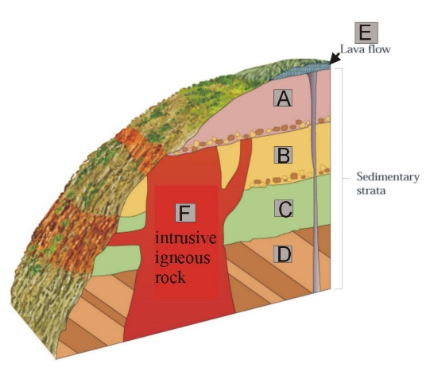
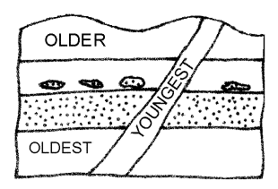
  - Clues from Faults
    - A fault is a ______________________ in Earth’s crust. Forces inside Earth cause movement of the rock on opposite sides of a fault.
    - A fault is always ________________________ than the rock it cuts through. To determine the relative age of a fault, geologists find the relative age of the most recent rock layer through which the fault slices.
- Gaps in the Geological Record
  - The geologic record of sedimentary rock layers is not always complete.
  - ___________________________ slowly builds layer upon layer of sedimentary rock.
  - Some of these layers may erode away, exposing an older rock surface.
  - Then deposition begins again, building a new rock layer.
  - The surface where new rock layers meet a much older rock surface beneath them is called an ______________________________.
  - An unconformity is a ______________ in geologic record.
  - An unconformity shows where some rock layers have been lost because of ________________.
  - Unconformities show where an old, eroded surface is in contact with a newer rock layer.

How are index fossils useful to geologists?
- If a type of organism existed for only a short period of time, its fossils would show up in a limited range of rock layers. These fossils are called ____________________________ fossils.
- Index fossils are fossils that are found in the rock layers of only one geologic age, and can be used to establish the ______________ of the rock layers.
- To date rock layers, geologists first give a relative age to a layer of rock at one location.
- Then they can give the same age to matching layers of rock at other locations.
- Certain fossils, called index fossils, help geologists match rock layers.
- To be useful as an index fossil, a fossil must be widely ____________________________ and represent a type of organism that existed only briefly.
- Index fossils are useful because they tell the relative ages of the rock layers in which they occur.

The Trilobite
- One example of an index fossil is a ______________________.
- Trilobites were a group of hard-shelled animals whose bodies had three distinct parts.
- They evolved in shallow seas more than ___________________ million years ago.

